### Security testing

|  |  |  |  |  |  |
| --- | --- | --- | --- | --- | --- |
| No. | Test Title | Pre-Condition | Test Steps | Expected Results | Actual Results |
| 01. | SQL injection | The form used in the system which is connected with the database should be used to perform this action | Type in SQL command in the form | The test result was as expected. | As expected. |

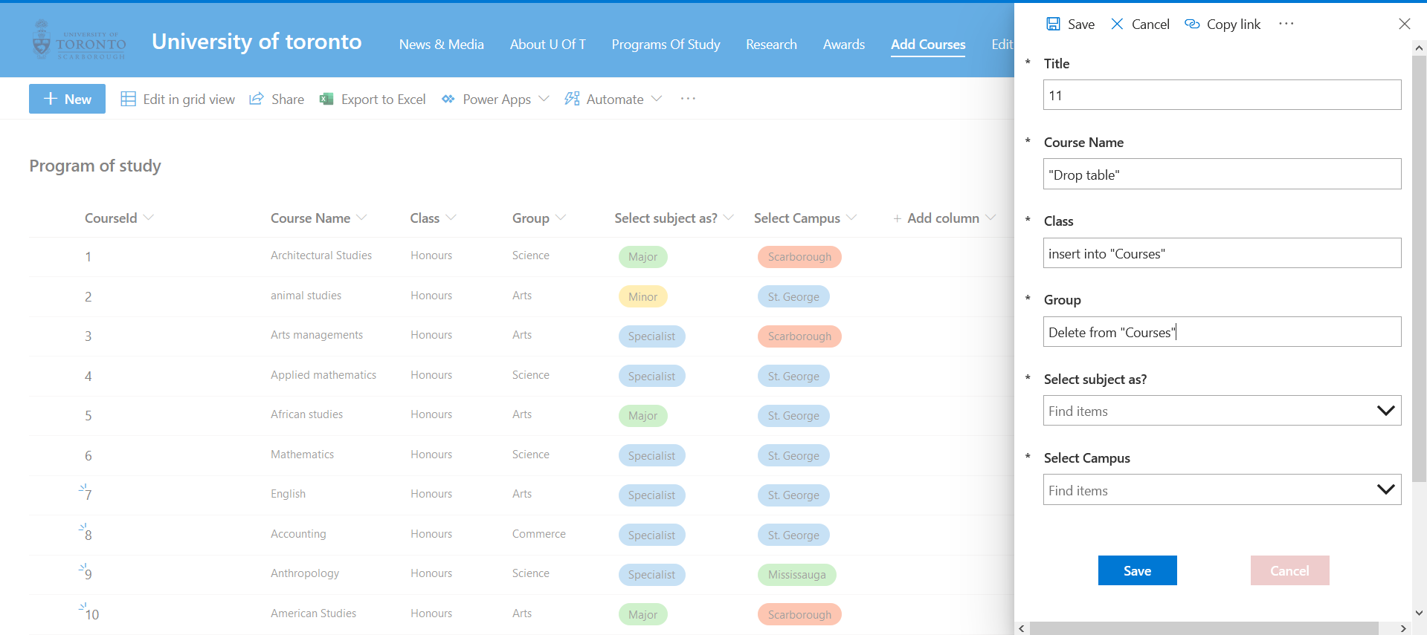

|  |  |  |  |  |  |
| --- | --- | --- | --- | --- | --- |
| No. | Test Title | Pre-Condition | Test Steps | Expected Results | Actual Results |
| 02. | Invalid password login system | The User needs to be logout from the CMS | Try inserting wrong password | The user will not be able to login to the system. | As expected. |

